GreenFeed Finalized Data Request Form

Only use this form if you are unable to complete the Google Form
https://forms.gle/kxu9Dr5F3qMp8yFU6

1) Which number(s) of the GreenFeed system(s) were used on this trial (Required)?

2) What is the date range you would like included in the finalized workbook (Required)?

3) What is the date range you would like included in the finalized workbook (Required)?

4) Did you fill out a pre-experiment checklist for this trial (Required)?
If you did not fill out a pre-experiment checklist for this trial, please follow the link below.
https://docs.c-lockinc.com/?s=pre-experiment+Checklist+greenfeed+.

5) Did any of your animals have multiple RFID Tags (Required)?
*If yes please make sure the data team has a copy of the cross-reference list of the multiple tags. Without this list, data may be affected.

6) Do you have anything to note about this data set or experiment (Required)?

7) Type of animals on trial: Beef, Dairy, Small Animals, Other

8) Breed of animals:

9) What type of diet were the animals on? TMR, Pasture/Grazing, Partial Mixed Ration, Hay, Other

10) Were animals fed a methane inhibitor? If yes, what was the methane inhibitor?

11) Upload a data file with your animal information. Please upload your data in the same format using the same column headers shown. In the pictures, see examples of the ancillary data files for dairy and beef animals. For the treatment column, the naming can be generic (i.e., A, B, etc. or Trt, Con). If your animals were not fed a treatment, please put NA.
For dairy animals, please include visual ID, RFID, breed, treatment (if applicable), parity, days in milk, milk production, and body weight and average dry matter intake, if available.
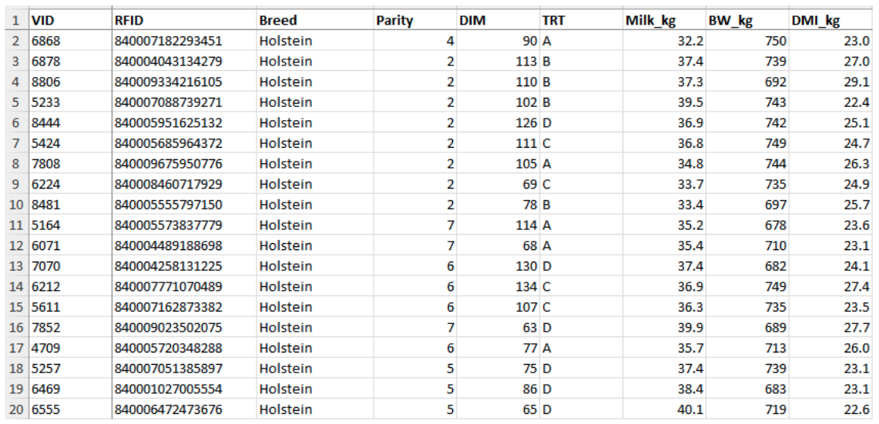

For beef cattle, please include visual ID, RFID, breed, treatment, estimated age, dry matter intake, average daily gain, and body weights(s), if available.
